Title: LOREN IPSUN LOREN IPSUN LOREN IPSUN LOREN IPSUN LOREN IPSUN LOREN IPSUN LOREN IPSUN LOREN IPSUN

Ana Maria da Silva^{a,b}, Elisa Tristan^{c}, Grace Furtado^{c}, Eduardo Siqueira^{d}

ª Mauricio Gastón Institute for Latino Community Development and Public Policy, University of Massachusetts Boston, Boston, MA 02125-3393, USA; ORCID: 0000-0000-0000-0000; Grace.modelsubmit@umb.edu;
^{b} FGV EMAp, Fundação Getulio Vargas FGV, Rio de Janeiro, RJ 22250-900, Brazil; ORCID: 0000-0000-0000-0000; modelsubmit@gmail.com;
^{c} Cambridge Health Alliance, Cambridge, MA 02139, USA; etristmodelsubmit@test.org;
^{d} School for the Environment, University of Massachusetts Boston, Boston, MA 02125-3393, USA; ORCID: 0000-0000-0000-0000; carlomodelsubit@edu.com.

Correspondent author: modelsubmit@gmail.com

ORCID and e-mails of all authors:
ª ORCID: 0000-0000-0000-0000;
^{b} ORCID: 0000-0000-0000-0000;
^{c} ORCID: 0000-0000-0000-0000;
^{d} ORCID: 0000-0000-0000-0000.

Authors summary
Why was this study done?
N ipsun loren ipsun loren ipsun loren ipsun loren ipsun loren ipsun loren ipsun.

What did the researchers do and find?
Ipsun loren ipsun loren ipsun loren ipsun loren ipsun loren ipsun loren ipsun.

What do these findings mean?
Psun loren ipsun loren ipsun loren ipsun loren ipsun loren ipsun loren ipsun.

Abstract:
Introduction: Psun loren ipsun loren ipsun loren ipsun loren ipsun loren ipsun loren ipsun.
Objective: Psun loren ipsun loren ipsun loren ipsun loren ipsun loren ipsun loren ipsun.
Methods: Psun loren ipsun loren ipsun loren ipsun loren ipsun loren ipsun loren ipsun. Psun loren ipsun loren ipsun loren ipsun loren ipsun loren ipsun loren ipsun.
Results: Psun loren ipsun loren ipsun loren ipsun loren ipsun loren ipsun loren ipsun. Psun loren ipsun loren ipsun loren ipsun loren ipsun loren ipsun loren ipsun. Psun loren ipsun loren ipsun loren ipsun loren ipsun loren ipsun loren ipsun.
Conclusion: Psun loren ipsun loren ipsun loren ipsun loren ipsun loren ipsun loren ipsun.

Keywords: 1; 2; 3; 4; 5; 6.
(we recommend that you use the descriptors available on the DECS / MESH platform)

Resumo:
Introdução: Psun loren ipsun loren ipsun loren ipsun loren ipsun loren ipsun loren ipsun.
Objetivo: Psun loren ipsun loren ipsun loren ipsun loren ipsun loren ipsun loren ipsun.
Método: Psun loren ipsun loren ipsun loren ipsun loren ipsun loren ipsun loren ipsun. Psun loren ipsun loren ipsun loren ipsun loren ipsun loren ipsun loren ipsun.
Resultado: Psun loren ipsun loren ipsun loren ipsun loren ipsun loren ipsun loren ipsun. Psun loren ipsun loren ipsun loren ipsun loren ipsun loren ipsun loren ipsun. Psun loren ipsun loren ipsun loren ipsun loren ipsun loren ipsun loren ipsun.
Conclusão: Psun loren ipsun loren ipsun loren ipsun loren ipsun loren ipsun loren ipsun.

Palavras-chave: 1; 2; 3; 4; 5; 6.
(recomendamos utilizar os descritores disponíveis na plataforma DECS / MESH)

INTRODUCTION
Loren ipsun loren ipsun loren ipsun loren ipsun loren ipsun loren ipsun loren ipsun loren ipsun loren ipsun loren ipsun loren ipsun loren ipsun loren ipsun loren ipsun loren ipsun loren ipsun loren ipsun loren ipsun loren ipsun loren ipsun loren ipsun loren ipsun loren ipsun loren ipsun loren ipsun loren ipsun loren ipsun loren ipsun loren ipsun loren ipsun loren ipsun loren ipsun loren ipsun loren ipsun loren ipsun loren ipsun loren ipsun loren ipsun loren ipsun loren ipsun loren ipsun loren ipsun loren ipsun loren ipsun loren ipsun loren ipsun¹. (citação numérica sequencial e em ordem crescente)
Ipsun loren ipsun loren ipsun loren ipsun loren ipsun loren ipsun loren ipsun loren ipsun loren ipsun loren ipsun loren ipsun². Loren ipsun loren ipsun loren ipsun loren ipsun loren ipsun loren ipsun loren ipsun loren ipsun loren ipsun loren ipsun loren ipsun loren ipsun loren. loren ipsun loren ipsun loren ipsun loren ipsun loren ipsun loren ipsun loren ipsun loren^{1,2}. Ipsun loren ipsun loren ipsun loren ipsun loren ipsun loren ipsun loren ipsun loren ipsun loren ipsun loren ipsun loren ipsun loren ipsun loren ipsun loren ipsun loren ipsun loren ipsun loren³.

Thus, the objective is ......... (inserir a seção objetivo)

METHODS

Study Design
Loren ipsun loren ipsun loren ipsun loren ipsun loren ipsun loren ipsun loren ipsun loren ipsun loren ipsun loren ipsun loren ipsun loren ipsun ipsun loren ipsun loren ipsun.

Study Location and Period
Loren ipsun loren ipsun loren ipsun loren ipsun loren ipsun loren ipsun loren ipsun loren ipsun loren ipsun loren ipsun loren ipsun loren ipsun n ipsun loren ipsun loren ipsun.

Study Population and Eligibility Criteria
Loren ipsun loren ipsun loren ipsun loren ipsun loren ipsun loren ipsun loren ipsun loren ipsun loren ipsun loren ipsun loren ipsun loren ipsun loren ipsun loren ipsun.

Data Collection
Loren ipsun loren ipsun loren ipsun loren ipsun loren ipsun loren ipsun loren ipsun loren ipsun loren ipsun loren ipsun loren ipsun loren ipsun loren ipsun ipsun loren ipsun.

Data Analysis
Loren ipsun loren ipsun loren ipsun loren ipsun loren ipsun loren ipsun loren ipsun loren ipsun loren ipsun loren ipsun loren ipsun loren ipsun loren ipsun loren ipsun loren ipsun loren ipsun.

Ethical and Legal Aspects of the Research
Loren ipsun loren ipsun loren ipsun loren ipsun loren ipsun loren ipsun loren ipsun loren ipsun loren ipsun loren ipsun loren ipsun loren ipsun loren ipsun loren ipsun loren ipsun loren ipsun.

RESULTS
Loren ipsun loren ipsun loren ipsun loren ipsun loren ipsun loren ipsun loren ipsun loren ipsun loren ipsun loren ipsun loren ipsun loren ipsun loren ipsun loren ipsun loren ipsun loren ipsun.
(Exemple)
Table 1. Loren ipsun loren ipsun loren ipsun loren ipsun loren ipsun loren ipsun loren ipsun loren ipsun loren ipsun loren ipsun loren ipsun loren ipsun loren ipsun loren ipsun loren ipsun loren ipsun
Variables | Total | % | Type I DM* | % | Type II DM* | % | DM* w/ HAS | %
Sample | 64,196 | 100 | 2512 | 3.9 | 6995 | 10.9 | 54,689 | 85.2
Sex
Male | 21,416 | 33.4 | 1138 | 45.3 | 2875 | 41.1 | 17,403 | 31.8
Female | 42,780 | 66.6 | 1374 | 54.7 | 4120 | 58.9 | 37,286 | 68.2
Age group
Up to 19 | 696 | 1.1 | 391 | 15.6 | 99 | 1.4 | 206 | 0.4
20 to 39 | 5219 | 8.1 | 672 | 26.8 | 995 | 14.2 | 3552 | 6.5
40 to 59 | 29,282 | 45.6 | 922 | 36.7 | 3,767 | 53.9 | 24,593 | 45.0
60 and + | 28,999 | 45.2 | 527 | 21.0 | 2,134 | 30.5 | 26,338 | 48.2
Source: SisHiperdia (DATASUS), 2019.
(Exemple)
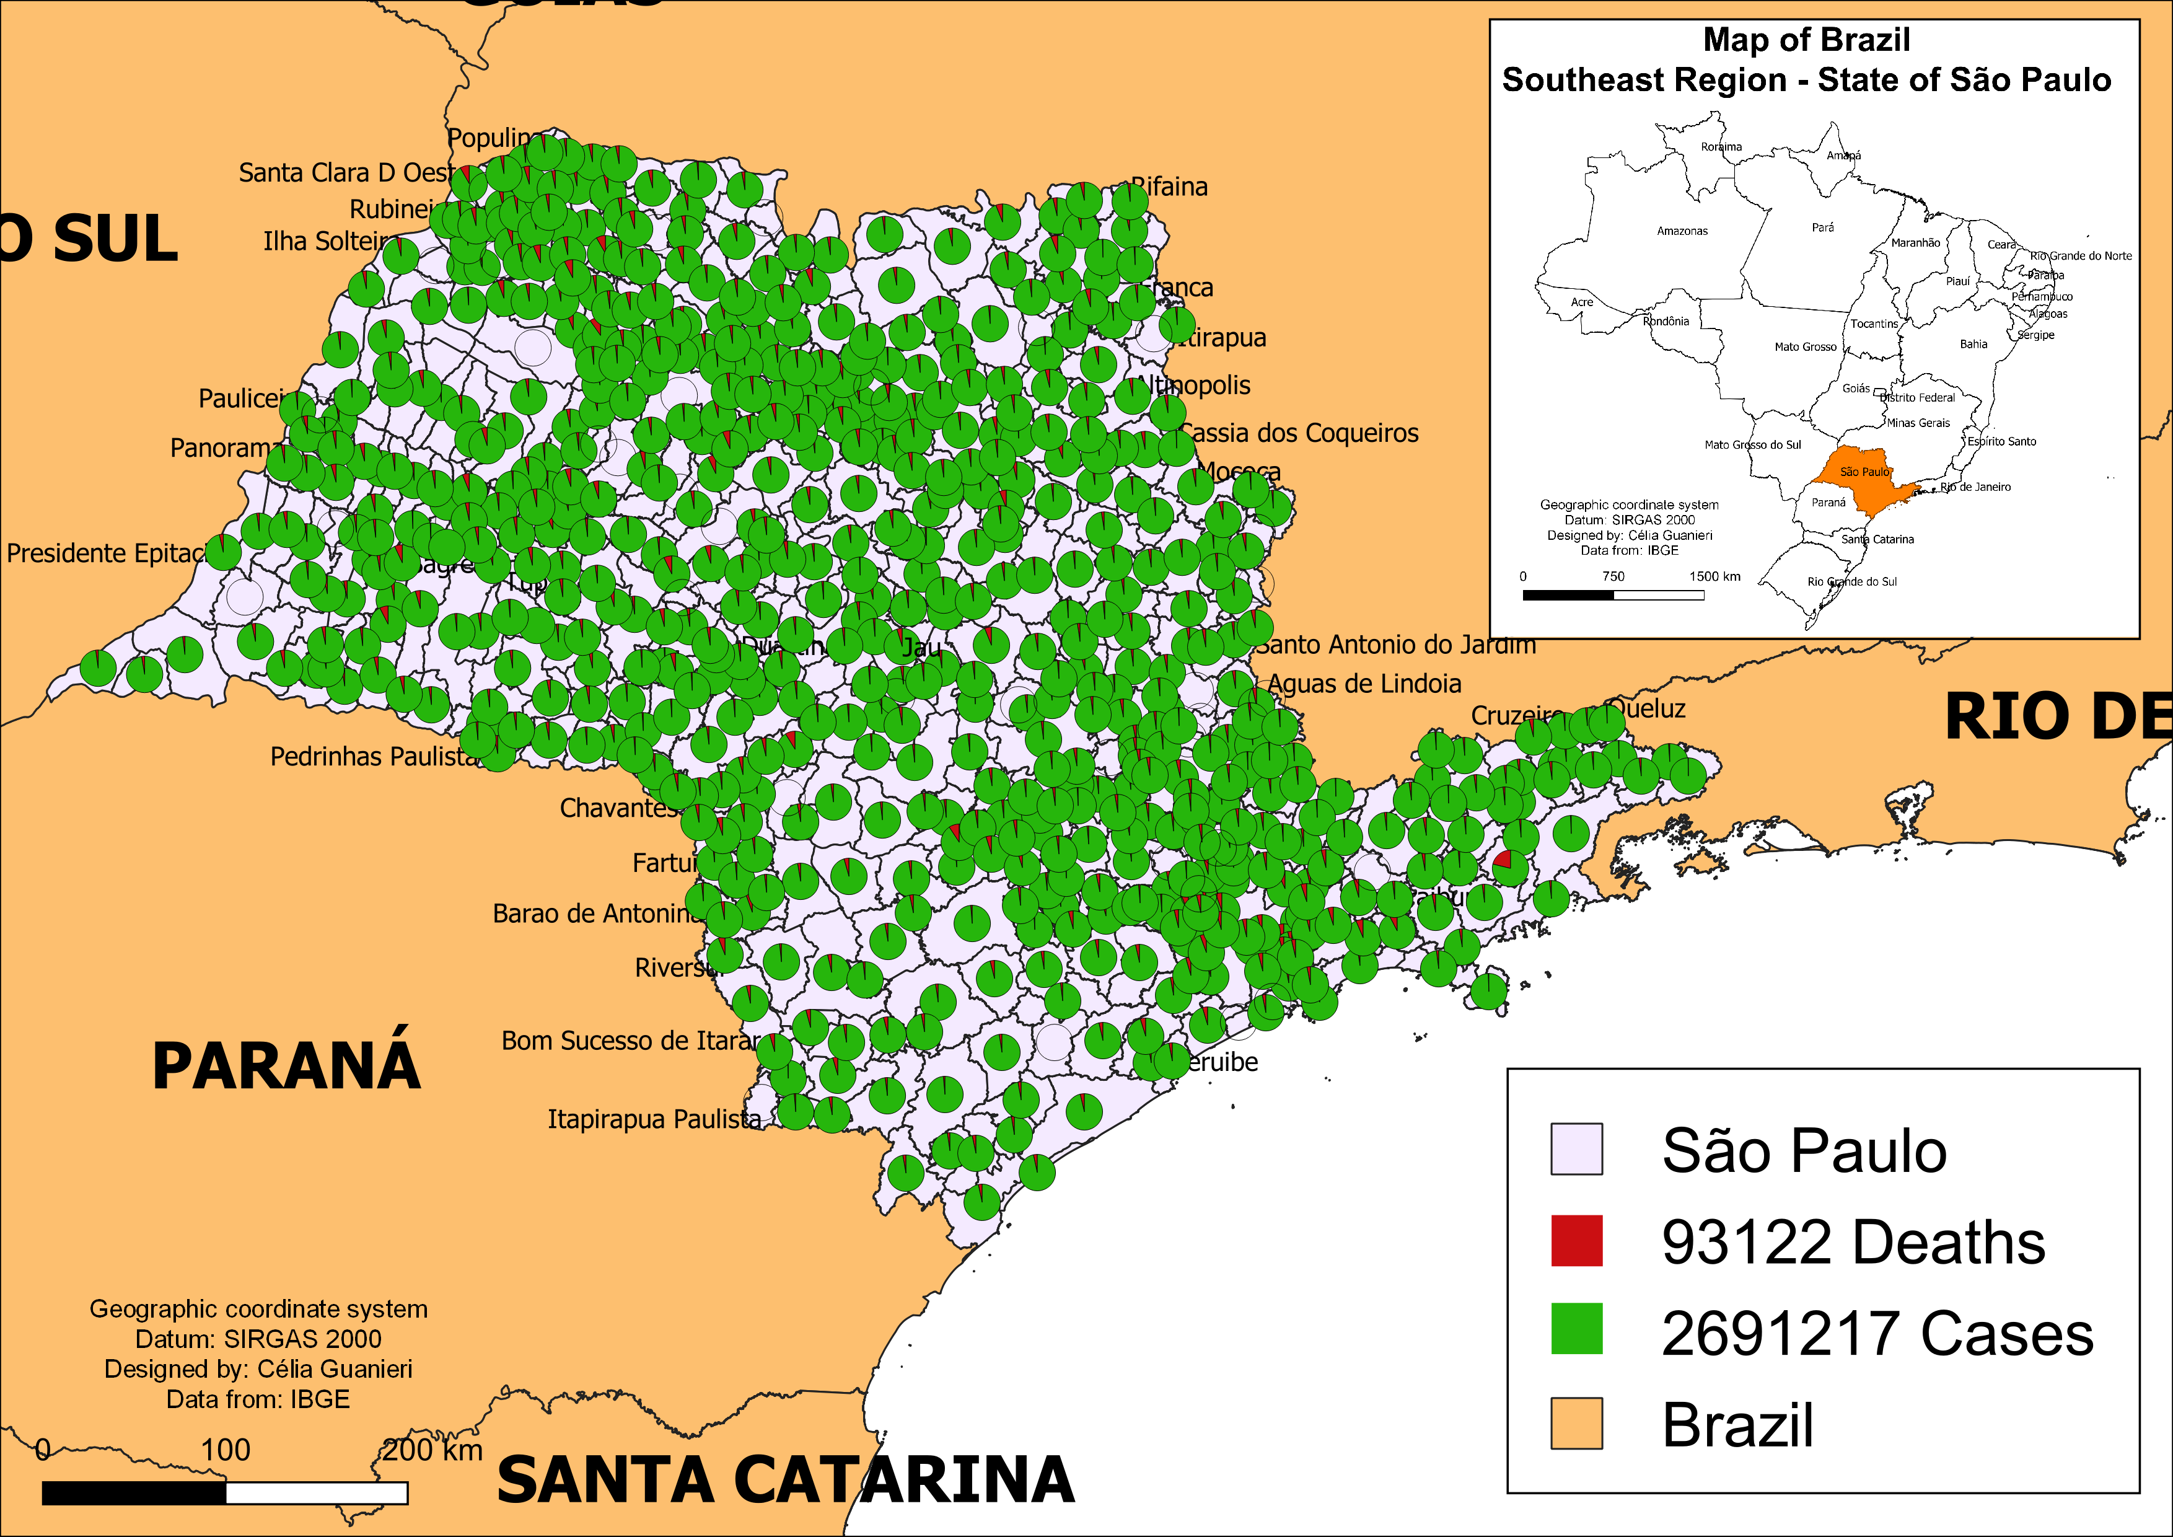
Figure 1. Loren ipsun loren ipsun loren ipsun loren ipsun loren ipsun loren ipsun loren ipsun loren ipsun loren ipsun loren ipsun loren ipsun loren ipsun loren ipsun loren ipsun loren ipsun loren ipsun

DISCUSSION
Loren ipsun loren ipsun loren ipsun loren ipsun loren ipsun loren ipsun loren ipsun loren ipsun. Loren ipsun loren ipsun loren ipsun loren ipsun loren ipsun loren ipsun loren ipsun loren ipsun loren ipsun loren ipsun loren ipsun loren ipsun loren ipsun loren ipsun loren ipsun loren ipsun.
Loren ipsun loren ipsun loren ipsun loren ipsun loren ipsun loren ipsun loren ipsun loren ipsun loren ipsun loren ipsun loren ipsun loren ipsun loren ipsun loren ipsun loren ipsun loren ipsun.

CONCLUSION
Loren ipsun loren ipsun loren ipsun loren ipsun loren ipsun loren ipsun loren ipsun loren ipsun loren ipsun loren ipsun loren ipsun loren ipsun loren ipsun loren ipsun loren ipsun loren ipsun.

Author Contributions: Loren ipsun loren ipsun loren ipsun loren ipsun loren ipsun loren ipsun loren ipsun loren ipsun

Funding: Loren ipsun loren ipsun loren ipsun loren ipsun loren ipsun loren ipsun loren ipsun loren ipsun

Acknowledgments: Loren ipsun loren ipsun loren ipsun loren ipsun loren ipsun loren ipsun loren ipsun loren ipsun

Conflicts of Interest: Loren ipsun loren ipsun loren ipsun loren ipsun loren ipsun loren ipsun loren ipsun loren ipsun

REFERENCES (Vancouver)
1 Loureiro RJ. Decision making in adolescents: a multifaceted construct. J Hum Growth Dev. 2020; 30(2): 160-163. DOI: https://doi.org/10.7322/jhgd.v30.10362
2 Abreu LC. Integrated actions and strengthening of Public Health System in Brazil in a time of pandemic. J Hum Growth Dev. 2020; 30(1): 05-08. DOI: https://doi.org/10.7322/jhgd.v30.9980
3 Bezerra IMP. State of the art of nursing education and the challenges to use remote technologies in the time of corona virus pandemic. J Hum Growth Dev. 2020; 30(1): 141-147. DOI: http://doi.org/10.7322/jhgd.v30.10087
4 Macedo CR. Immunoprevention: a course of decades and the challenge to tackle false information. J Hum Growth Dev. 2019; 29(3): 299-303. DOI: https://doi.org/10.7322/jhgd.v29.9522
5 Afonso M, Barros EPM, Cavalcanti MPE, Ribeiro MAL. An essay on individual self-determination. J Hum Growth Dev. 2019; 29(2): 131-135. DOI: http://doi.org/10.7322/jhgd.v29.9412

© 2024 by the authors. Submitted for possible open access publication under the terms and conditions of the Creative Commons Attribution (CC BY) license (http://creativecommons.org/licenses/by/4.0/).

