TITLE: subtitle (if applicable)
Author
Author
Author
ABSTRACT: Informative of a maximum of 250 words in the original language of the article. It must be formatted in Calibri 11 font, single space. It must include an introduction to the topic, objective(s), methodological procedures, results/discussions and conclusions. It must be accompanied by 3 to 5 keywords in the original language of the article, separated by a period.
Keywords: Public Policies. University. Scientific Journal. Article.
TÍTULO: subtítulo (se aplicável)
RESUMO: Texto informativo de no máximo 250 palavras na língua original do artigo. Deve ser formatado em fonte Calibri 11, espaço simples. Deve incluir introdução ao tema, objetivo(s), procedimentos metodológicos, resultados/discussões e conclusões. Deve ser acompanhado de 3 a 5 palavras-chave na língua original do artigo, separadas por ponto.
Palavras-Chave: Políticas Públicas. Universidade. Periódico Científico. Artigo.
TÍTULO: subtítulo (si aplicable)
RESUMEN: Texto informativo de un máximo de 250 palabras en el idioma original del artículo. Debe estar formateado en fuente Calibri 11, espacio simple. Debe incluir una introducción al tema, objetivo(s), procedimientos metodológicos, resultados/discusiones y conclusiones. Debe ir acompañado de 3 a 5 palabras clave en el idioma original del artículo, separadas por un punto.
Palabras clave: Políticas Públicas. Universidad. Revista Científica. Artículo.
1 INTRODUCTION
All original documents must be sent through the Open Journal Systems (OJS) platform, version OJS 3.3.0.11. The document must be saved in .DOC or .DOCX (Microsoft Word) format, formatted and standardized in accordance with the Template and the recommendations of the RIPPMar Editorial Policy. All metadata must be filled in: document title, document subtitle (if any), abstract, keywords, name(s) full details of the author(s), last academic degree, affiliation, email, ORCID, Lattes, telephone and postal address.
Documents can be written in Portuguese, English or Spanish. If the original text is written in English, prepare the second and third abstracts in Portuguese and Spanish. If the original text is written in Spanish, prepare the second and third abstracts in Portuguese and English.
Documents that do not contain academic-scientific language or grammatical and/or spelling errors are not accepted. The author is responsible for the translation (when applicable), spelling and/or grammatical corrections, as well as the style of the submission. The Editorial Team may make small style and layout corrections while editing the text to adapt it to RIPPMar's editorial standards for publication.
The document must be formatted in accordance with the RIPPMar Template . The style used in each part of the template must be identified with the prefix RIPPMar, for example: “1-RIPPMar-Title of Article 1” to facilitate identification.
2 DEVELOPMENT
The content of the document must be typed in 1.5cm space, with margins of 3cm (top and left) and 2cm (bottom and right), the page must be A4 size. Pages must be numbered. The formatting of the body of the text is Calibri 12 font. The body of the text (paragraphs) must be justified and typed with 1.5cm spacing between lines. The first line of the paragraph must be offset by 1.25 cm.
The document must be organized into topics, and each section must be typed in capital letters (upper case) such as: SUMMARY, INTRODUCTION, THEORETICAL FRAMEWORK, METHODOLOGICAL PROCEDURES, RESULTS ANALYSIS, CONCLUSION, etc.).
According to RIPPMar (2023, p. 34):
Quotes with more than three lines must be blocked, use 4cm indentation, single spacing, spacing before and after 6pt. All citations appear in the references and use ABNT NBR:10520 (2023). The accuracy of the citations used to prepare the content must be consistent.
Citations with less than three lines must comply with the ABNT NBR:10520 (2023) standard.
Figures, graphs, charts and tables must begin the title with a capital letter, use font size 11, in bold. The font information must be provided below, use font size 10, in bold.
Figure 1: Submission Guidelines
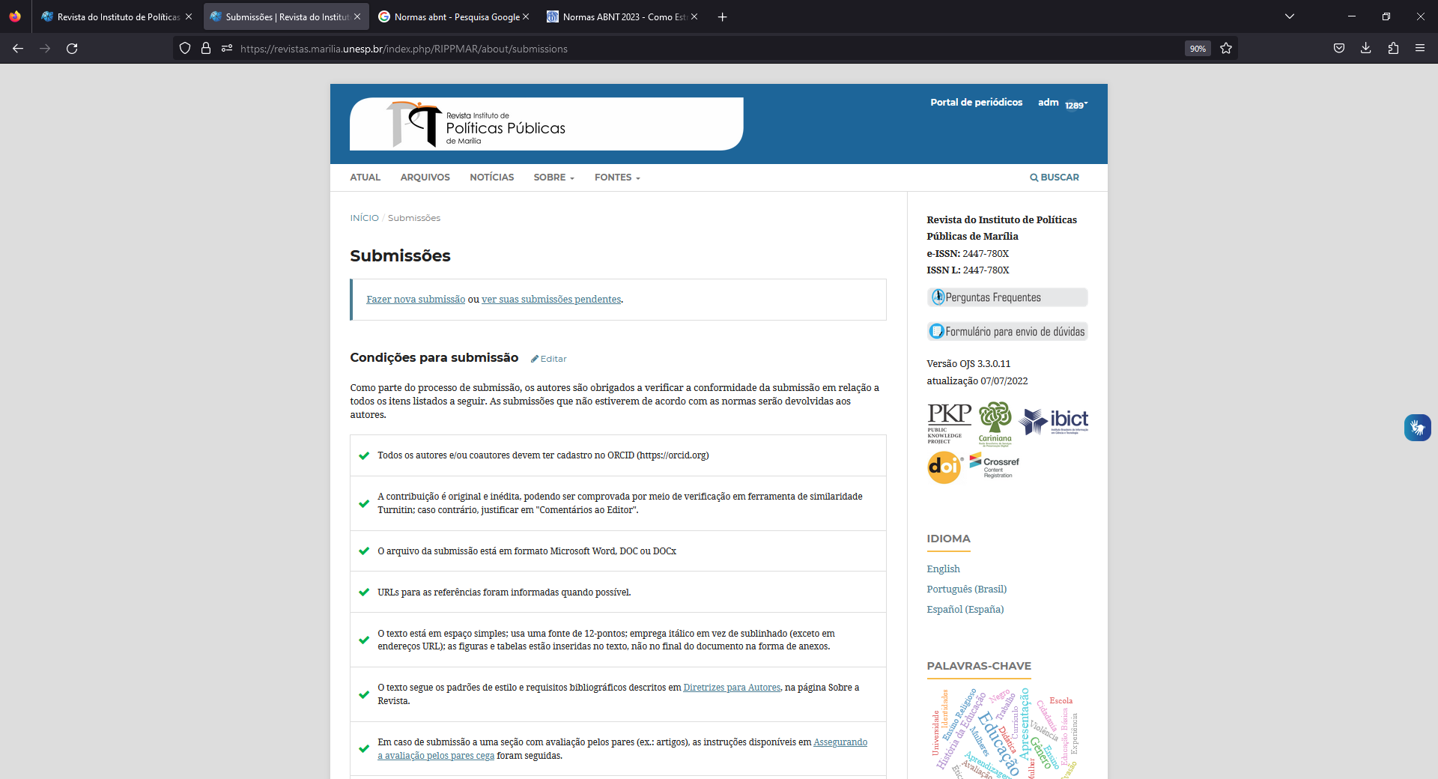
Source: https://revistas.marilia.unesp.br/index.php/RIPPMAR/about/submissions.
Table 1: Number of articles
Quantity of Articles | 2019 | 2020 | 2021 | Total | %Total
Gender | two | 3 | 1 | 6 | 20%
Social assistance | 1 | 1 | 3 | 5 | 17%
Student stay | 1 | 0 | two | 3 | 10%
Health | two | two | 1 | 5 | 17%
Education | 3 | two | two | 7 | 23%
Others | 1 | two | 1 | 4 | 13%
Total | 10 | 11 | 12 | 30 | 100%
Source: RIPPMar (2022).
Table 1: Qualitative data
Article Quality | Relevance | Consistency
Articles about public health policies | High | Great
Articles about public policies in Education | High | Great
Articles about public policies in the Environment | High | Great
Articles on public policies in Economics | High | Great
Source: RIPPMar (2024).
2.1 Observations
Articles must be original and written by the author(s). All names mentioned in the authorship field must have effectively contributed to the work and preparation of the article.
Every document submission on RIPPMar's OJS platform is checked with the iThenticate software, a TurnItIn product that is a similarity and plagiarism checking tool.
The author(s) should be aware that any violation of copyright, intellectual property laws and codes of ethics are unacceptable and prohibited in this journal.
2.2 Body Text Formatting
The formatting of the body of the text is Calibri 12 font. Paragraphs must be justified and with 1.5 cm spacing between lines. The first line must have an offset of 1.25cm.
Do not use underlining, bold or capital letters in the body of the text. Use capital letters in accordance with the spelling rules of the language in which the text is written and for acronyms. Do not use spaces or periods in acronyms.
3 CONCLUSION
There are no restrictions on the total number of references to be included to prepare the document. Do not include references that were not cited in the document and do not fail to cite in the body of the text the references that were actually used to prepare the document. It is recommended that the primary document be cited, avoiding the use of quotation citations (apud) or revisions in order to give credit to the source or the original author of the idea, data or information presented.
The author(s) must comply with ABNT standards regarding: 'Abstract' (NBR:6028); 'Article in periodical publication' (NBR:6022), 56); 'Progressive numbering of sections of a written document' (NBR:6024); 'Academic works' (NBR:14724); 'Norm for dating' (NBR:5892); as well as the tabular presentation standard of the Brazilian Institute of Geography and Statistics (IBGE) ( https://biblioteca.ibge.gov.br/visualizacao/livros/liv23907.pdf ).
REFERENCES
All references were cited and use ABNT NBR:6023/2018. The accuracy of the references used to prepare the content must be consistent. The author(s) must verify that they are correct.
It is necessary to comply with the following rules:
- Text alignment: left.
- Spacing: single between lines.
- Source: Calibri, size 11.
- Order: alphabetical and NOT numbered.
- Space one blank line between each reference.

Affiliation, last academic degree, ORCID and email.
Affiliation, last academic degree, ORCID and email.
Affiliation, last academic degree, ORCID and email.

